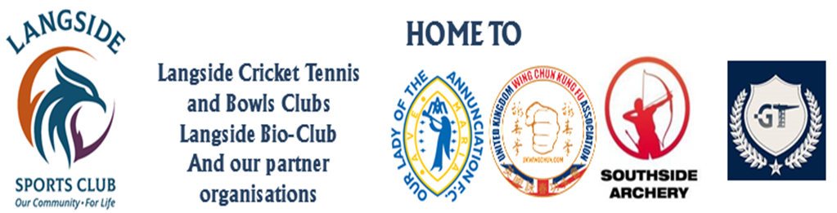
OLA FC
Training Kit Order Form
(to be completed by player’s parent/guardian)

Player’s Name

Age Group & Team
(e.g. 2015 Avengers)
Squad Number
(if applicable)
Date

Item |  | Price | Size |  |  |  | Qty.
 |  | Price | 5/6 | 7/8 | 9/11 | 12/13 | Qty.
Shirt |  | £8.50
Shorts |  | £7.50
Football Socks |  | £5.00
Training kit (shirt, shorts, socks) |  | £18.00
Zipped Hoodie |  | £14.50
Training pack (full kit + zipped hoodie) |  | £31.92
Tracksuit Jacket |  | £16.00
Tracksuit Trousers |  | £14.00
Full tracksuit |  | £28.00
Beanie Hat |  | £7.50
Skip Cap |  | £9.50
Club Bag |  | £19.50
Total Package (a Club Bag with one of every item packed inside) |  | £85.00

