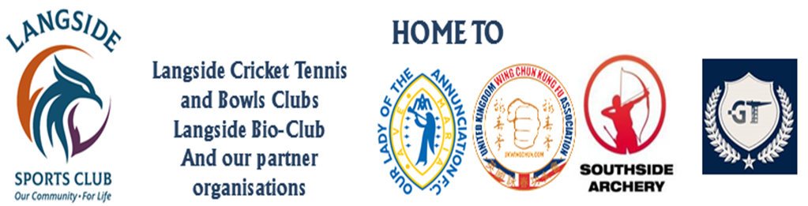
OLA FC
Playing Kit Order Form(to be completed by team lead coach)
Coach’s Name
Age Group and Team
(e.g. 2015 Avengers)
Date submitted
Item | Size and Quantity  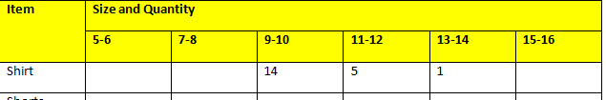  Please note number of items and sizes required. See example, right.
Item | 5-6 | 7-8 |  | 9-10 | 11-12 | 13-14 | 15-16
Shirt
Shorts
Socks
Rainjacket
Date Collected

Coach Kit Order Form
Coach’s Name
Age Group
Date Ordered
Item | Size and Quantity
Item | S |  | M | L | XL | XXL
Polo Shirt
Shorts | No. of Pairs |  |  | Sizes
Socks
Rainjacket
Tracksuit Top
Tracksuit Trousers
Date Collected

